Project Development Phase
Model Performance Test
Date | 16 September 2026
Team ID
Project Name | Medical Diagnostic Center – ServiceNow
Maximum Marks | 10 Marks
Model Performance Testing
S.No. | Parameter | Screenshot / Values
1 | Data Rendered | ServiceNow Service Portal renders diagnostic tests, patient appointments, appointment status, payment status, and laboratory reports. Screenshot: 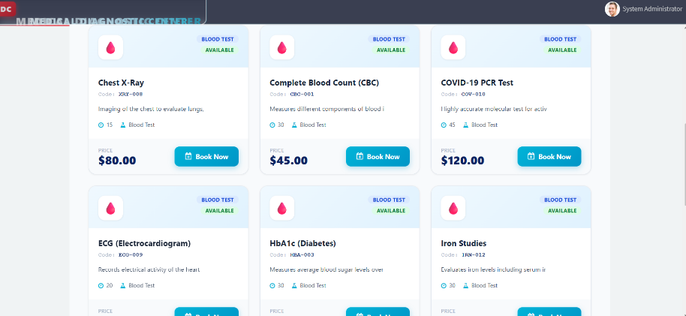
2 | Data Preprocessing | Data is validated and processed through ServiceNow tables, Client Scripts, Business Rules, and GlideRecord. Patient, appointment, test, and report records are linked through ServiceNow reference fields. Screenshot: 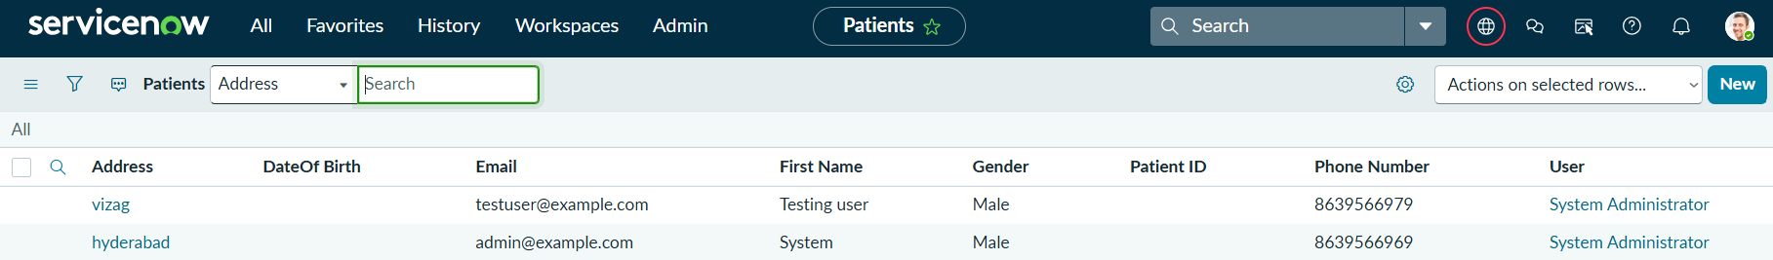
3 | Utilization of Data Filters | Search, sorting, and filtering are implemented in the My Appointments and My Lab Reports sections to help patients find relevant records. Screenshot: 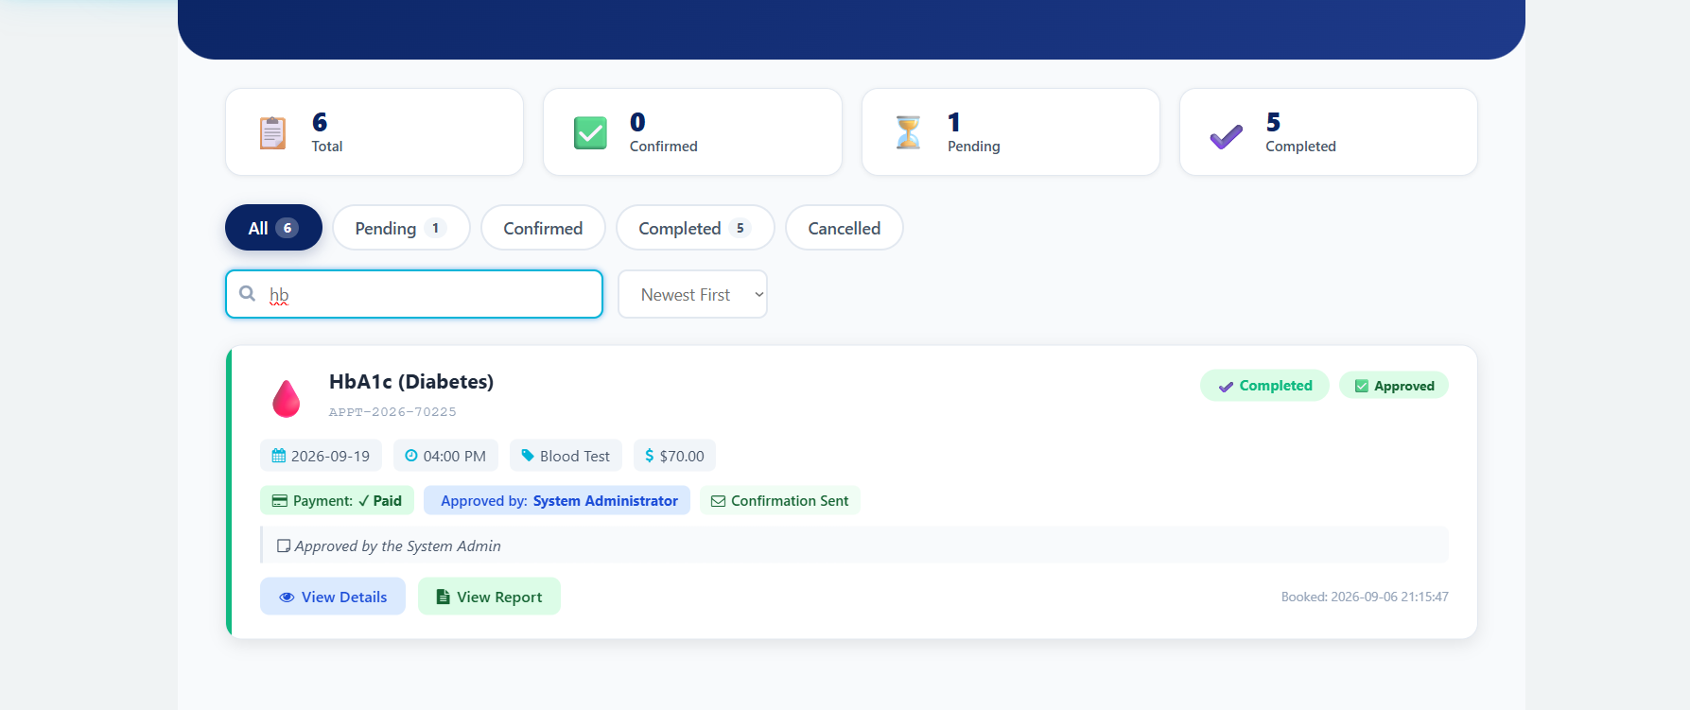
4 | DAX Queries Used | Not Applicable (N/A) – The project does not use Power BI or DAX. ServiceNow server-side JavaScript and GlideRecord are used instead.
5 | Dashboard Design | ServiceNow Service Portal provides the application interface and information cards/widgets. No. of Visualizations / Graphs: N/A – no Power BI graphs are used. Screenshot 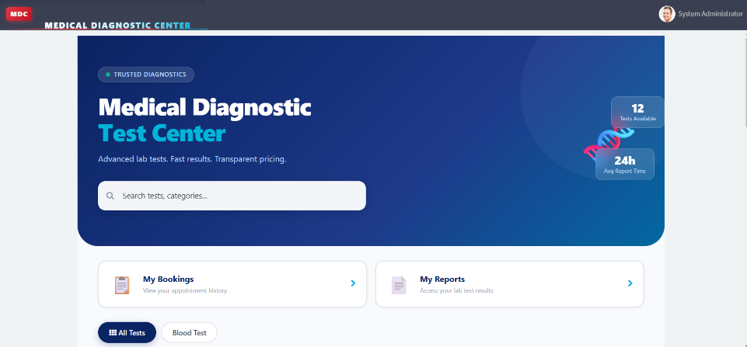
6 | Report Design | Laboratory reports are displayed through the My Lab Reports Service Portal widget, including report number, test, report date, status, verified doctor, and findings. No. of Visualizations / Graphs: N/A. Screenshot:

